**Packet Tracer - VLAN Configuration**

**Addressing Table**

|  |  |  |  |  |
| --- | --- | --- | --- | --- |
| **Device** | **Interface** | **IP Address** | **Subnet Mask** | **VLAN** |
| PC1 | NIC | 172.17.10.21 | 255.255.255.0 | 10 |
| PC2 | NIC | 172.17.20.22 | 255.255.255.0 | 20 |
| PC3 | NIC | 172.17.30.23 | 255.255.255.0 | 30 |
| PC4 | NIC | 172.17.10.24 | 255.255.255.0 | 10 |
| PC5 | NIC | 172.17.20.25 | 255.255.255.0 | 20 |
| PC6 | NIC | 172.17.30.26 | 255.255.255.0 | 30 |

**Objectives**

**Part 1: Verify the Default VLAN Configuration**

**Part 2: Configure VLANs**

**Part 3: Assign VLANs to Ports**

**Background**

VLANs are helpful in the administration of logical groups, allowing members of a group to be easily moved, changed, or added. This activity focuses on creating and naming VLANs, and assigning access ports to specific VLANs.

**Part 1: View the Default VLAN Configuration**

**Step 1: Display the current VLANs.**

On S1, issue the command that displays all VLANs configured. By default, all interfaces are assigned to VLAN 1.

**Step 2: Verify connectivity between PCs on the same network.**

Notice that each PC can ping the other PC that shares the same subnet.

·         PC1 can ping PC4

·         PC2 can ping PC5

·         PC3 can ping PC6

Pings to hosts on other networks fail.

Question:

What benefits can VLANs provide to the network?

**Part 2: Configure VLANs**

**Step 1: Create and name VLANs on S1.**

a.     Create the following VLANs. Names are case-sensitive and must match the requirement exactly:

·         VLAN 10: Faculty/Staff

*Open configuration window*

S1#(config)# **vlan 10**

S1#(config-vlan)# **name Faculty/Staff**

b.     Create the remaining VLANS.

·         VLAN 20: Students

·         VLAN 30: Guest(Default)

·         VLAN 99: Management&Native

·         VLAN 150: VOICE

**Step 2: Verify the VLAN configuration.**

Question:

Which command will only display the VLAN name, status, and associated ports on a switch?

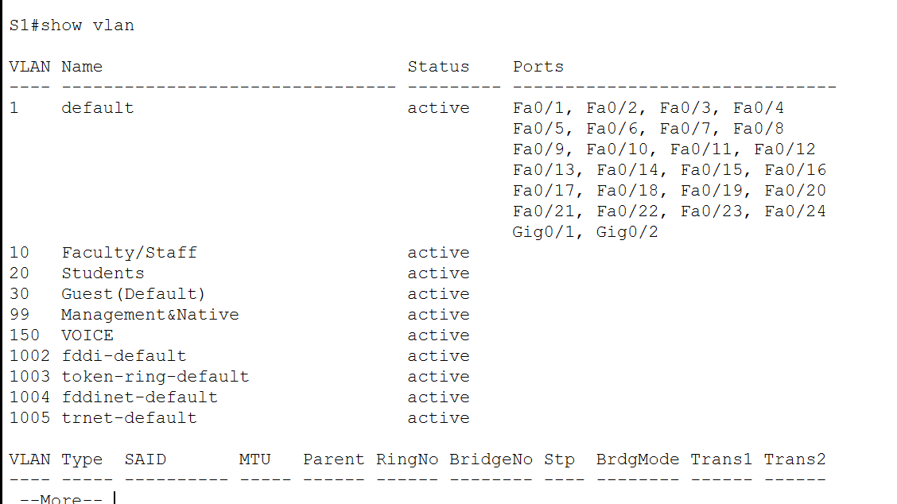

**Step 3: Create the VLANs on S2 and S3.**

Use the same commands from Step 1 to create and name the same VLANs on S2 and S3.

**Step 4: Verify the VLAN configuration.**

*Close configuration window*

**Part 3: Assign VLANs to Ports**

**Step 1: Assign VLANs to the active ports on S2.**

a.     Configure the interfaces as access ports and assign the VLANs as follows:

·         VLAN 10: FastEthernet 0/11

*Open configuration window*

S2(config)# **interface f0/11**

S2(config-if)# **switchport mode access**

S2(config-if)# **switchport access vlan 10**

b.     Assign the remaining ports to the appropriate VLAN.

·         VLAN 20: FastEthernet 0/18

·         VLAN 30: FastEthernet 0/6

**Step 2: Assign VLANs to the active ports on S3.**

S3 uses the same VLAN access port assignments as S2. Configure the interfaces as access ports and assign the VLANs as follows:

·         VLAN 10: FastEthernet 0/11

·         VLAN 20: FastEthernet 0/18

·         VLAN 30: FastEthernet 0/6

**Step 3: Assign the VOICE VLAN to FastEthernet 0/11 on S3.**

As shown in the topology, the S3 FastEthernet 0/11 interface connects to a Cisco IP Phone and PC4. The IP phone contains an integrated three-port 10/100 switch. One port on the phone is labeled Switch and connects to F0/4. Another port on the phone is labeled PC and connects to PC4. The IP phone also has an internal port that connects to the IP phone functions.

The S3 F0/11 interface must be configured to support user traffic to PC4 using VLAN 10 and voice traffic to the IP phone using VLAN 150. The interface must also enable QoS and trust the Class of Service (CoS) values assigned by the IP phone. IP voice traffic requires a minimum amount of throughput to support acceptable voice communication quality. This command helps the switchport to provide this minimum amount of throughput.

S3(config)# **interface f0/11**

S3(config-if)# **mls qos trust cos**

S3(config-if)# **switchport voice vlan 150**

**Step 4: Verify loss of connectivity.**

Previously, PCs that shared the same network could ping each other successfully.

Study the output of from the following command on **S2** and answer the following questions based on your knowledge of communication between VLANS. Pay close attention to the Gig0/1 port assignment.

S2# **show vlan brief**

VLAN Name Status Ports

---- -------------------------------- --------- -------------------------------

1 default active Fa0/1, Fa0/2, Fa0/3, Fa0/4

Fa0/5, Fa0/7, Fa0/8, Fa0/9

Fa0/10, Fa0/12, Fa0/13, Fa0/14

Fa0/15, Fa0/16, Fa0/17, Fa0/19

Fa0/20, Fa0/21, Fa0/22, Fa0/23

Fa0/24, Gig0/1, Gig0/2

10 Faculty/Staff active Fa0/11

20 Students active Fa0/18

30 Guest(Default) active Fa0/6

99 Management&Native active

150 VOICE active

Try pinging between PC1 and PC4.

Questions:

Although the access ports are assigned to the appropriate VLANs, were the pings successful? Explain.

What could be done to resolve this issue?

Ze zitten niet op zelfde vlan

*Close configuration window*

*End of document*